1. If_then_LED_ON

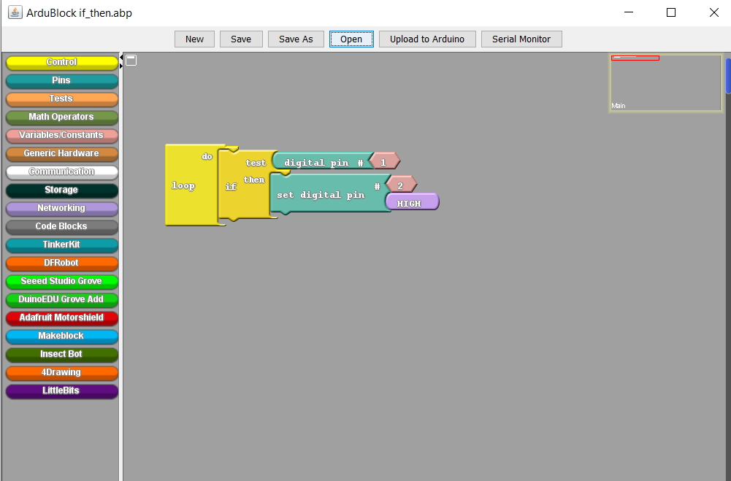

1. If_then_else_LED

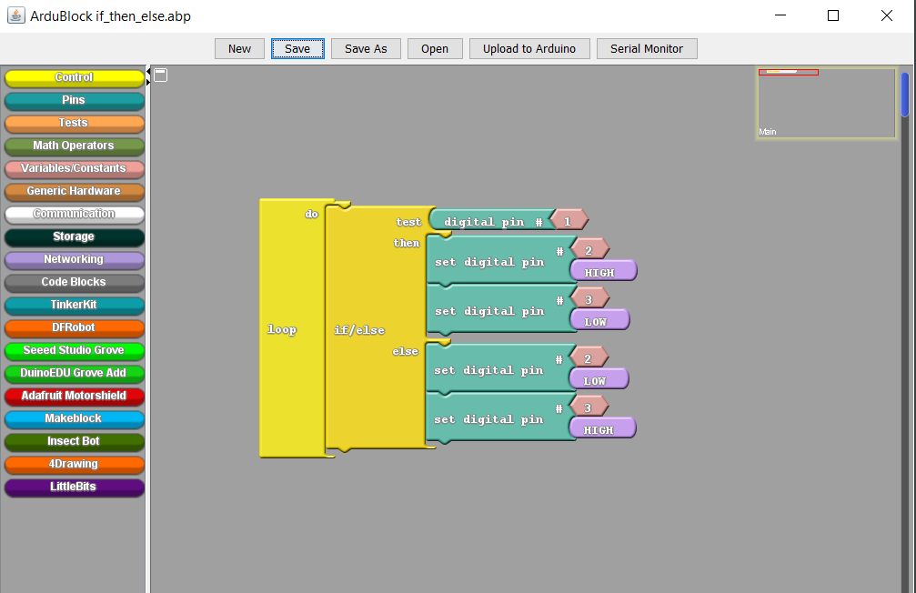

1. Switch_LEDblink

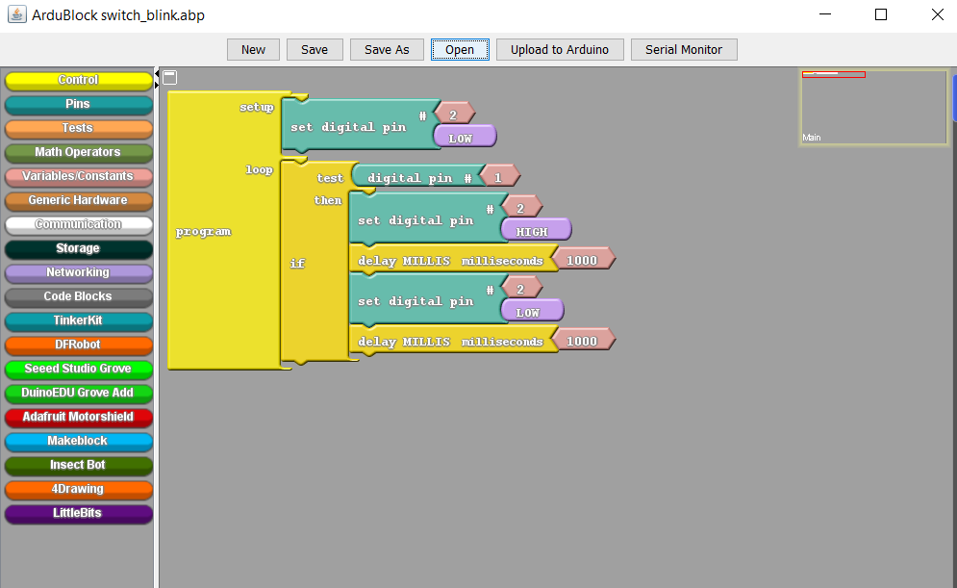

1. Switch_LEDblink_sketch

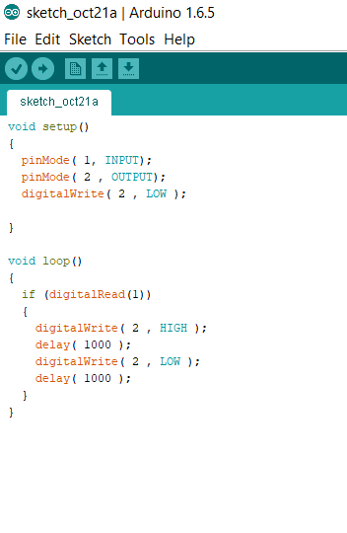

1. Analog_LED_Blink

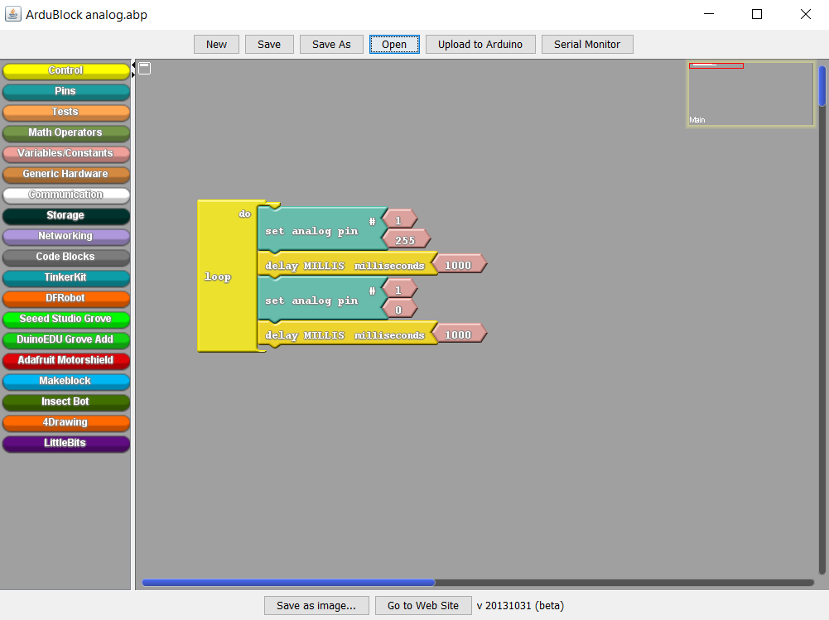

1. Potentiometer_LED_ON

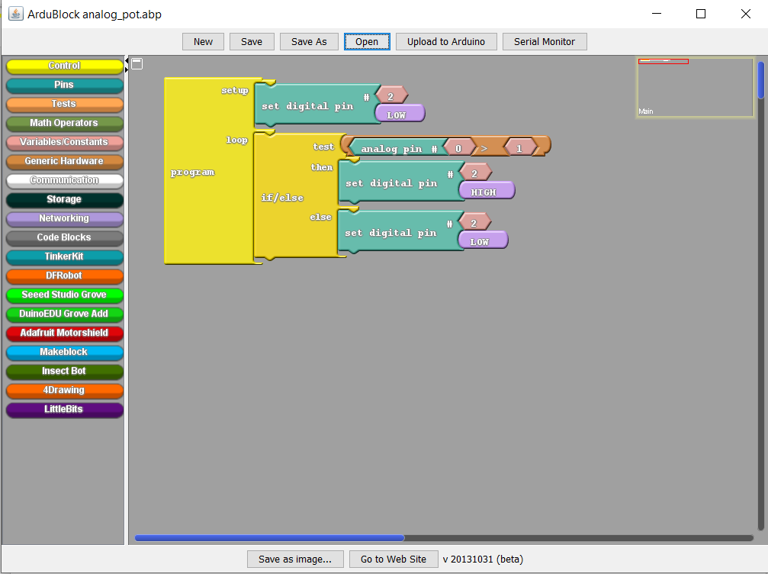

1. Potentiometer_LED_Blink

